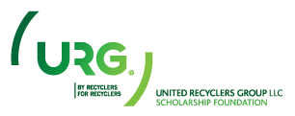

AUTHORIZATION AGREEMENT FOR ACH WITHDRAWAL

Business Name: Click here to enter text.

Phone: Click here to enter text.
City, State, Zip: Click here to enter text.

I hereby authorize United Recyclers Group, LLC, hereinafter called URG, to withdraw the amount of $Click here to enter text. on Click here to enter a date. as a tax-deductible donation to the URG Scholarship Foundation.

Account Type: Choose an item.

Bank Name: Click here to enter text.

Bank Address: Click here to enter text.

Routing Number: Click here to enter text. Account Number: Click here to enter text.

I acknowledge that the origination of ACH transactions to my account must comply with the provisions of U.S. law. I understand that the URG Scholarship Foundation is a 501(C)(3) Nonprofit Corporation and that I will receive a receipt for tax purposes.

Name: Click here to enter text. Title: Click here to enter text.

Signature: _____________________________________ Date: Click here to enter a date.
Please email signed copy to admin.scholarship@u-r-g.com or fax to 303-367-4409.

JM 2/16

