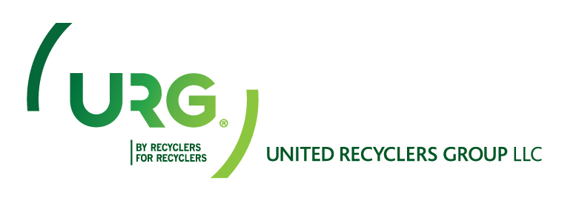
Press Release.
Auto insurers accused of pushing “junk yard parts” and cheap, dangerous repairs.
CNN Report:
On Feb. 11, Anderson Cooper 360 released a report detailing the way auto insurance companies coerce body shops into using cheap parts and dangerous practices to save money. As in many of these types of stories the information provided is mostly one sided and prepared in a manner to create controversy. It is to the detriment of CNN Viewers that CNN failed to truly investigate the allegations being made and interview automotive part suppliers, especially Automotive Recyclers, to gain valuable insight into the quality of recycled parts being supplied to the collision industry. CNN’s report is irresponsible and appears to have been styled to sensationalize the story.
In an effort to keep our members informed regarding current events, products and news related stories: URG provided information regarding the CNN Story and the video link in our February newsletter the “RECYCLERS ROUNDUP”. Although this story was included in that publication URG felt that a response to the characterization of recycled parts as "Junk Yard Parts" was required!

Automotive recyclers provide a valuable service to consumers by placing quality recycled OEM parts back into the market place. The inclusion of these parts in automotive repairs reduces expenses associated with both mechanical and collision repair and helps control the cost of NEW OEM parts. Today's recyclers are astute business owners committed to providing quality products and service to their customers. Labeling recycled parts as "inferior junkyard parts” mischaracterizes not only the quality of the parts being sold in the marketplace, but also the business entities that make up the automotive recycling industry.
Automotive manufacturers advertise the parts they produce and use in the construction of their vehicles are built to last the life of the vehicle. Automotive recyclers merely repurpose the Original Equipment Manufactured parts and provide consumers an alternative market where parts may be purchased at a more competitive price. Auto recyclers remain committed to providing quality parts and service. Today’s recyclers incorporate quality control measures and processes within their businesses to ensure the quality of the automotive parts they supply to all of their customers, including collision repair facilities, mechanical repair facilities and the “do it yourselfer”.
The quality of automotive repairs is not necessarily dependent on the type of part used in the repair process, although the quality of an individual recycled, new OEM part or aftermarket part could be a factor. Other factors — such as the quality of the repair processes and standards established and maintained by the collision repair facility, the competency and skill level of the auto body technicians repairing the vehicle and whether timely and effective communication is maintained between the collision repairer and the insurance carrier — may all contribute either positively or negatively to the quality and safety of the completed repairs.

The collision industry and automobile insurance companies both want their customers to receive quality safe repairs. However, insurers are seeking to receive those quality and safe repairs at competitive prices. Utilizing a mix of quality recycled parts, and OEM parts can help the insurer and the collision repair facilities both achieve their goals.

Any effort to get CNN to retract any of this story or provide a non-slanted investigational follow up will undoubtedly fall on deaf ears. We hope that vehicle owners across the nation understand that today’s recyclers are astute business owners dedicated to providing quality products and services to all of their customers. They stand behind what they sell!

United Recyclers Group members are dedicated to serving the Collision Industry and the Insurance Industry by supplying quality recycled OEM parts.

URG is proud of the industry we serve and the quality and integrity of our members companies.

Donald C Porter CEO
United Recyclers Group, LLC

Established in 1995, United Recyclers Group, LLC is the largest progressive association of automotive recyclers in North America. . With over 400 partners and over 525 locations throughout the US and Canada, URG is dedicated to helping our member companies improve the quality of the products and services they provide their customers. URG’s mission is to develop products and services to support our members and enhance their ability to sustain long term growth.

